**Janet B. MacLeod**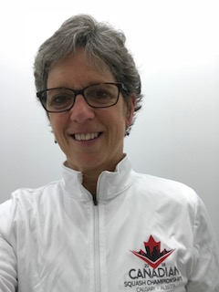

B.Ed, ChCP

NCCP Level 3

Advanced Coaching Diploma

Learning Facilitator and Evaluator

Chair, Coaching Committee Squash Canada

Grade 7 Teacher

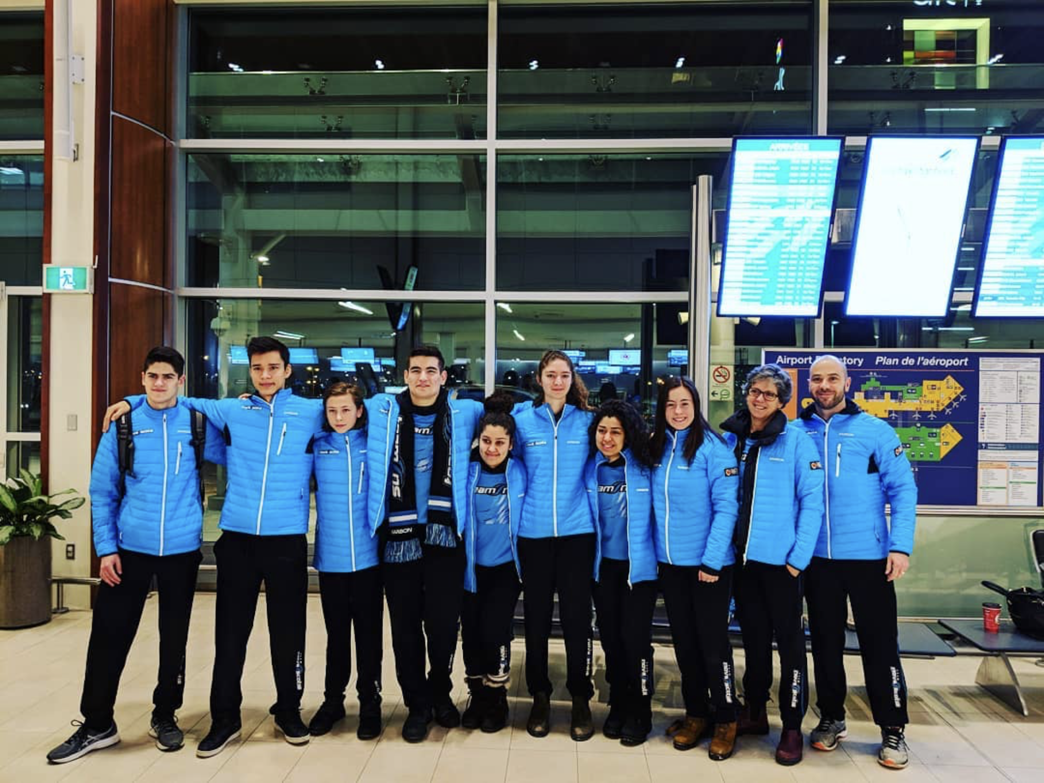

Janet MacLeod, resides in the Annapolis Valley of Nova Scotia where she implemented and runs the local junior program, from Little Racquets to High Performance, and Women’s programs on the 2 courts of her home club, the Kings County Squash Club in Kentville. As the Squash Nova Scotia Provincial Coach, Janet has been very involved in developing the Provincial Junior squad in Nova Scotia. She was the Head Squash Coach for both the 2015 and 2019 Canada Winter Games. She has represented Squash Canada as the Manager and Assistant Coach of the National Junior Women’s team at 3 World Junior Championships; The Netherlands in 2015, New Zealand in 2017 and most recently in Malaysia in 2019. She was named Head Coach of the Canadian Junior Women’s squash team that competed at the Pan American Junior Squash Championships in Brazil in 2018 and 2019 in Toronto, Canada, where the girls won Gold! 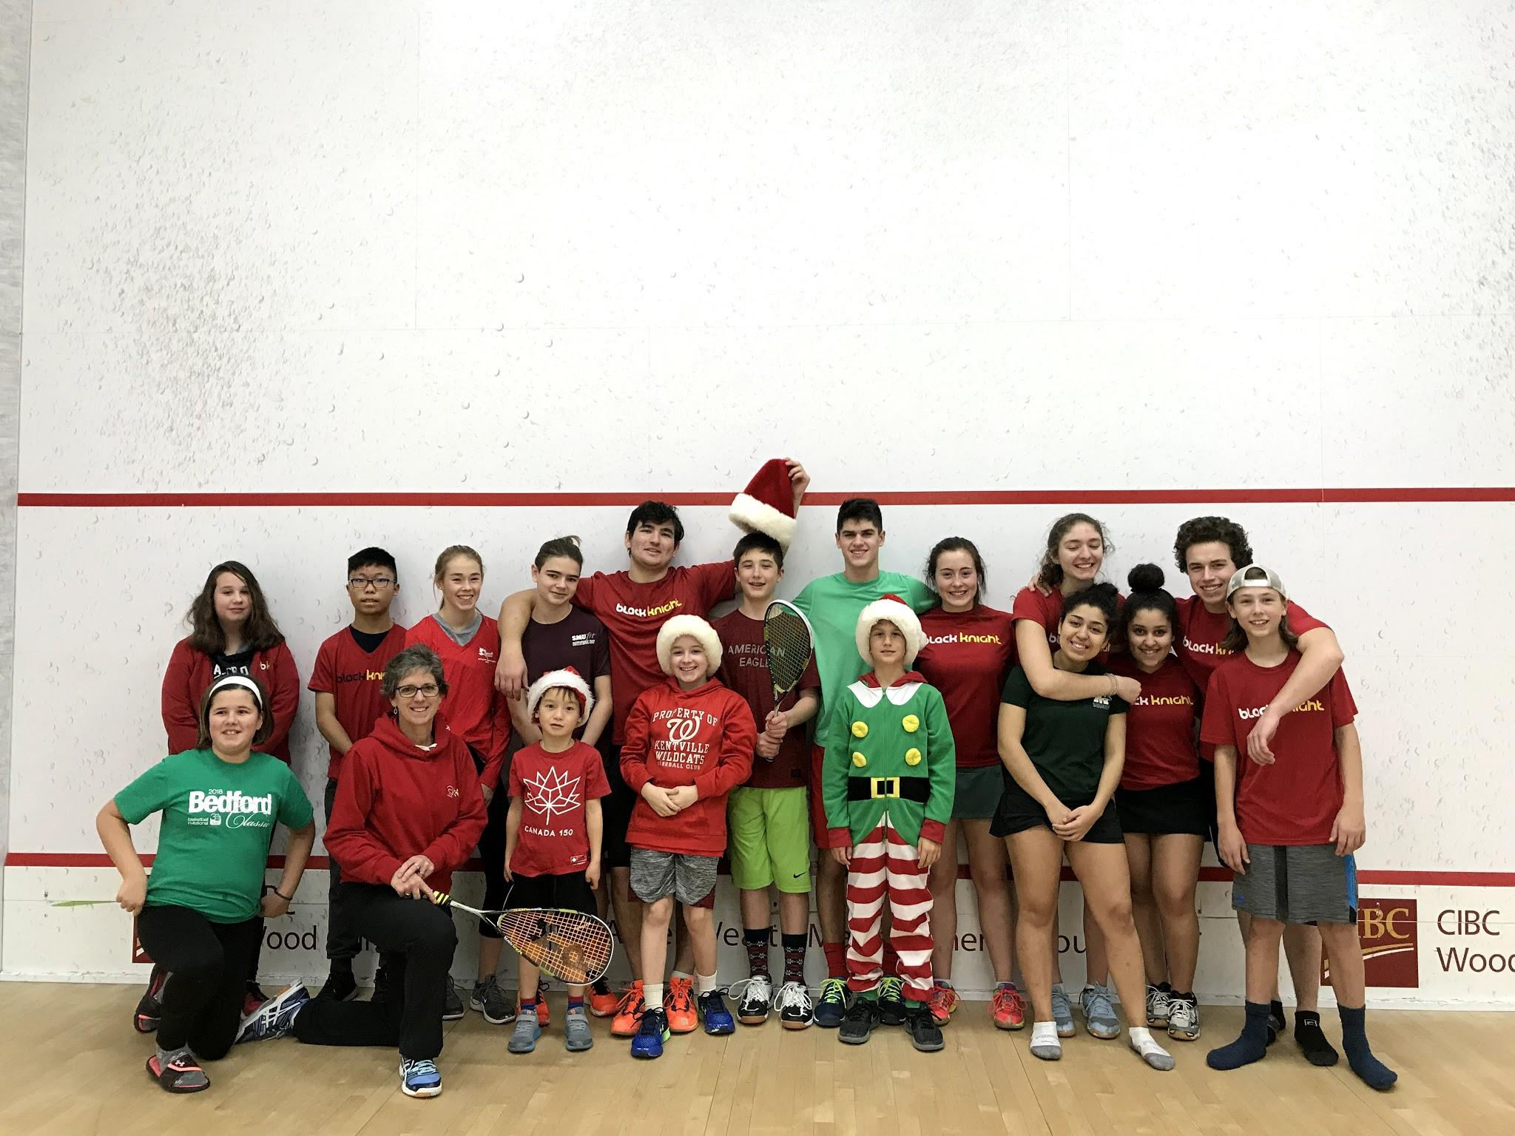

As a player, Janet has represented Nova Scotia for over 35 years. An active Masters age player now, Janet competed in the 2018 World Masters Squash Championships, where she placed 11th in her age group. When not on a squash court, Janet is a full time grade 7 teacher. She is also the mother of 3 grown daughters, all very active in sports and wellness, and she is the spouse of a Kinesiology Professor and Athletic Therapist. 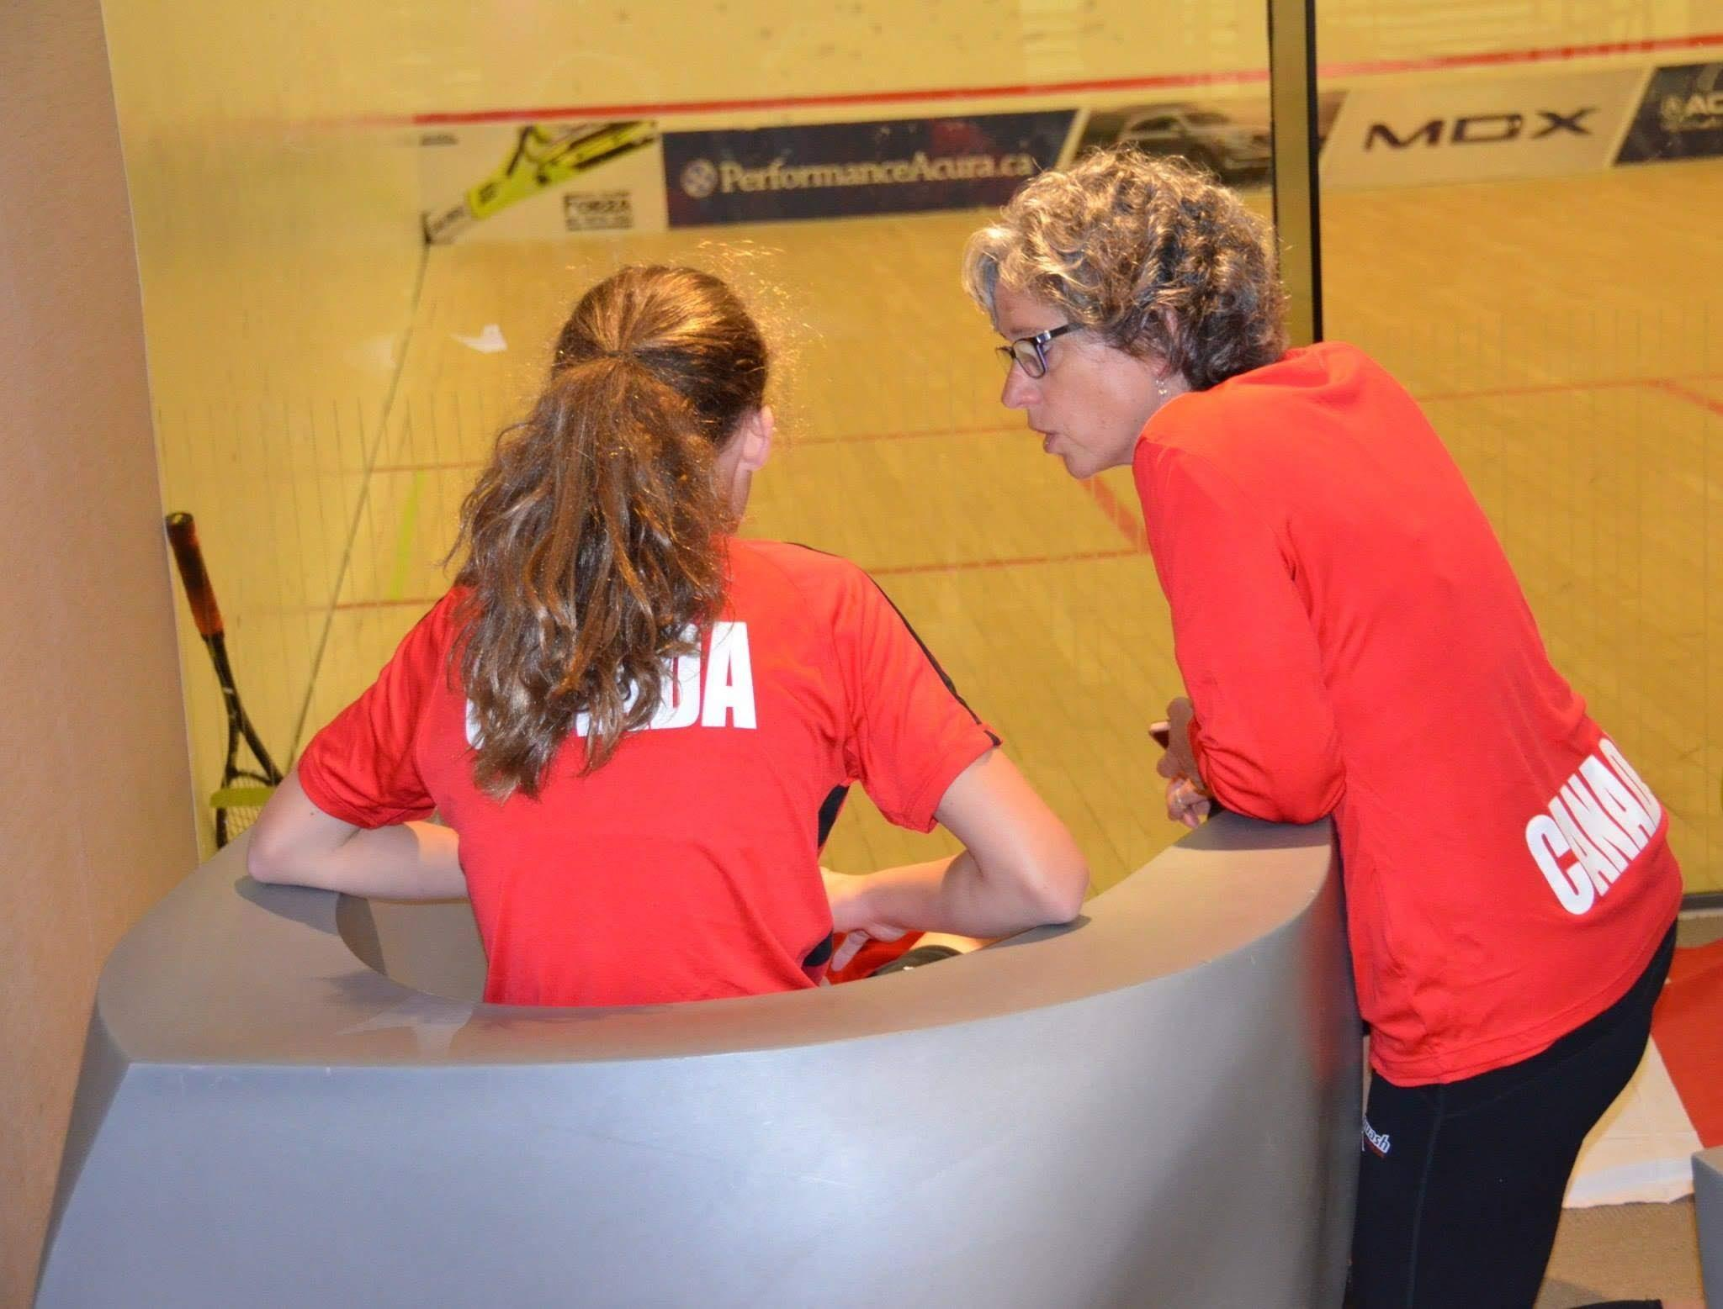

Janet is passionate about encouraging women, men and youth to play the game of squash as it is a game for life. Much of Janet’s energy and involvement in this great game comes from how squash can facilitate and benefit the growth and development of young people.